March 13, 2025
FOR IMMEDIATE RELEASE

The 2025 AWP Conference & Bookfair Gathers Literary Community in Los Angeles

Norfolk, VA — The Association of Writers & Writing Programs (AWP) will bring the literary community together in Los Angeles, California, for the AWP Conference & Bookfair on March 26–29. This annual event is the premier gathering for writers, educators, editors, and publishers. With 375 in-person events, more than 50 hours of virtual programming, and over 500 exhibitors, #AWP25 offers unparalleled opportunities to connect with the literary community.

AWP’s mission is to amplify the voices of writers and the institutions that serve them while championing diversity and excellence in creative writing. Their annual conference is the largest literary event in the US, welcoming 8,000–10,000 attendees.
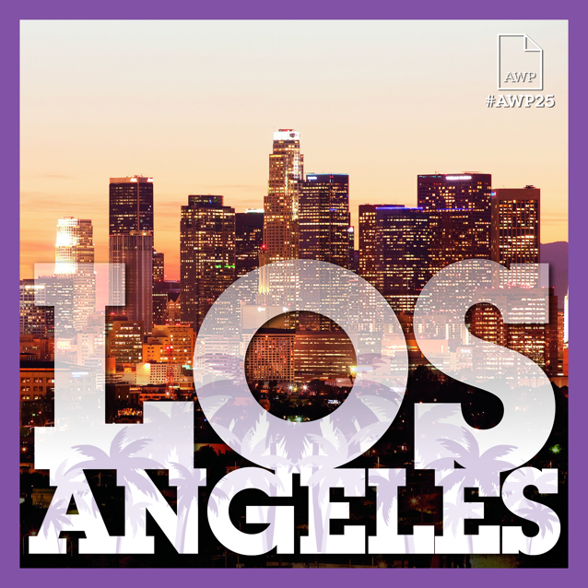
“AWP is grateful to be welcomed to Los Angeles, where we will bring our literary community together to celebrate and support the city amidst these challenging times. With a dynamic lineup of programming and featured events, we look forward to a meaningful, memorable experience for all attendees at #AWP25,” says Interim Executive Director Michelle Aielli.

AWP Awards Reception & Benefit for LA Fire Recovery
In response to the recent wildfires in Los Angeles, AWP is committed to giving back to the city that is welcoming the conference. On Wednesday, March 26, AWP will present the AWP Awards Reception & Benefit for LA Fire Recovery sponsored by Live Talks Los Angeles, an evening dedicated to raising funds for the local communities while recognizing literary excellence in its many forms. The event will be hosted by third-generation Angeleno Amber Tamblyn, actress and author of Dark Sparkler.

The event will honor the winners of the AWP George Garrett Award for Outstanding Community Service in Literature, the AWP Small Press Publisher Award, and the AWP Writing Organization Award, among other literary awards. Attendees will have the opportunity to make direct donations to Arts for LA throughout the evening.
#AWP25 Keynote Address with Roxane Gay
AWP is thrilled to welcome author and cultural critic Roxane Gay as the conference keynote speaker. Gay is the author of Bad Feminist and Opinions, among other acclaimed books. With her signature blend of incisive analysis, wit, and bold critique, Gay will kick off the conference on Thursday, March 27, at 8:00 p.m. PT.
AWP Tribal Colleges & Universities Fellowship Program
Tribal communities have long nurtured emerging literary talent, producing some of today’s most influential voices in literature. AWP is honored to provide space for this talent through the AWP Tribal Colleges & Universities Fellowship Program. Jake Skeets will serve as its inaugural creative advisor and will present his lecture, “Emergence & Becoming—Framing Native Poetics Beyond the ‘Renaissance’,” on Saturday, March 29.

AWP HBCU Fellowship Program & HBCU MFA Think Tank
The AWP HBCU Fellowship Program returns for its third year, with Tayari Jones as its creative advisor. Her lecture, “Black Words Are Black Wealth” sponsored by IngramSpark, discusses the long legacy of HBCUs and the path forward for the Black writers who attend or teach at them.

AWP is also proud to host the HBCU MFA Think Tank at #AWP25, in which creative writing educators from HBCUs across the nation will convene to explore the viability of MFA programs at HBCUs, where none currently exist.

“AWP has always been a space for writers to connect, create, and inspire one another. #AWP25 in Los Angeles continues that tradition while embracing the city’s vibrant literary and artistic communities,” says AWP Board Chair January O’Neil. “We are especially proud to support initiatives such as the HBCU MFA Think Tank and the AWP Tribal Colleges & Universities Fellowship Program, which expand opportunities for emerging voices. We look forward to gathering in LA to celebrate the power of words and the resilience of our community.”

For interview requests or more information on #AWP25, please email awpPR@awpwriter.org.

